Why Building Learning Power?

We are aiming to focus on BLP in order to
encourage creative thinking about the ways in
which children can become better learners.

BLP consists of 4 key learning dispositions

Knowing how to get through
Resilience difficulties when the going get
tough.

Using both internal and
external resources Resourcefulness
effectively.

Reflectiveness Taking a longer-term
view by planning and
taking stock.

Learning alone or with
others, communicating Reciprocity
and empathising

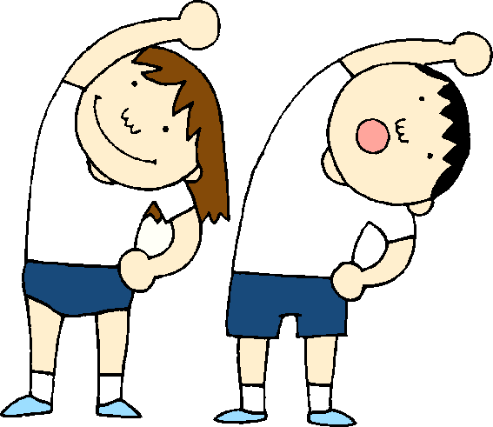

We can think of the dispositions as being like ‘Learning Muscles’. Developing the dispositions will encourage children to be aware of how they learn and achieve life-long learning.

BLP is:

Practical Enjoyable Flexible

Based on research on the brain

This term our focus is on building the power of resilience. Our Tough Tortoise is an image you will see around school. Tough Tortoise is a sticker! He doesn’t give up! Below you can see the images for the other learning powers.
