What is the Coronavirus?
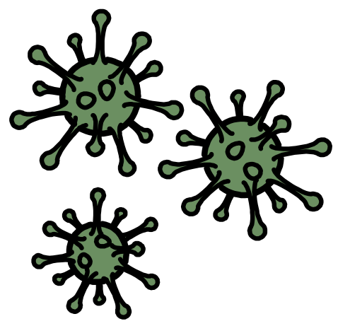

Dear parents / Carers,

This is a quick Social Story you may wish to share with your child if they have been worried about the Coronavirus.

As a Social Story, it provides limited information on the subject and is not meant to worry the children in any way.

If you or your child require more factual information about Coronavirus please go to the following;
https://www.nhs.uk/conditions/coronavirus-covid-19/

https://www.bbc.co.uk/newsround/

At the back of this Social Story you will find a summary sheet and a guide to washing your hands.

If you have any worries or concerns then please do not hesitate to contact us.

The Coronavirus is a virus that can make people feel unwell.
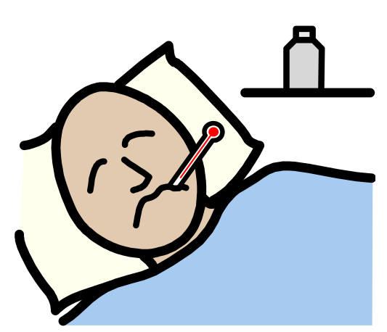

The Coronavirus can also be called “COVID-19”.

COVID-19 / CORONAVIRUS
People who have the Coronavirus may feel unwell.

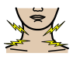 | 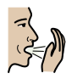 | 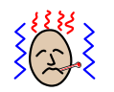 | 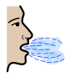
Sore throat | Dry cough | Fever | Shortness of breath

It feels a bit like getting flu.

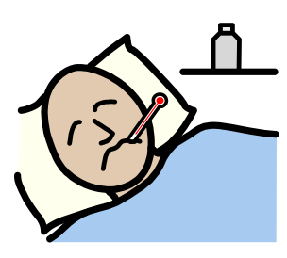

Most people who have the Coronavirus will stay at home to get better.

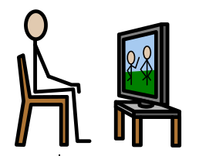

Some people who have the Coronavirus will go to the hospital to get better.
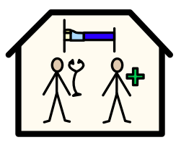
Most people get better by:
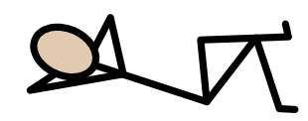 | 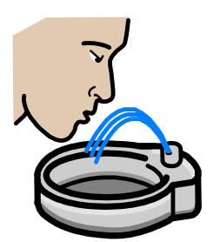 | 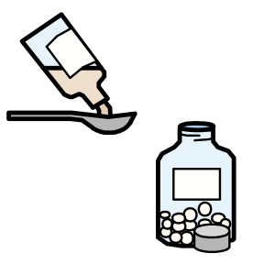
resting | drinking lots of water | taking pain medicine

I can help stop the spread of Coronavirus germs by washing my hands with soap and warm water for at least 20 seconds.
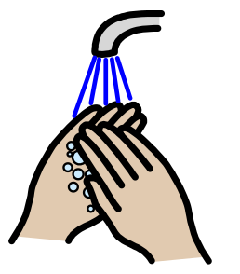
If I can’t use soap I can use Hand Sanitizer.
I can sing the “Happy Birthday” song twice while washing my hands. This makes sure I washed my hands for a full 20 seconds.

If I need to cough or sneeze I should catch it in a tissue.
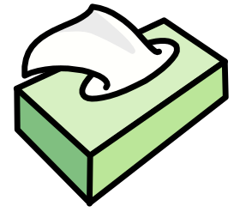
I should throw all dirty tissues in the bin and wash my hands.
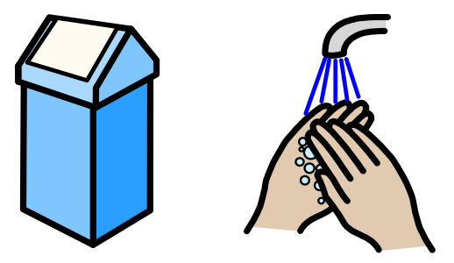

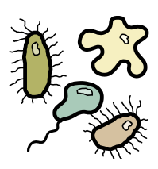
It is very important that I wash my hands often, to get rid of any germs…

…especially before and after the following activities. This well help stop the virus from spreading.
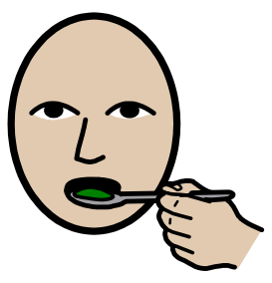 | 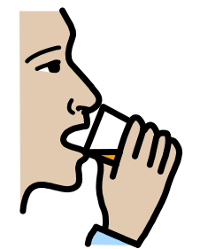 | 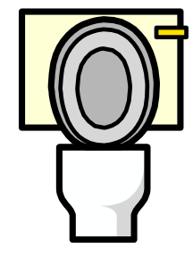
eating | drinking | going to the toilet
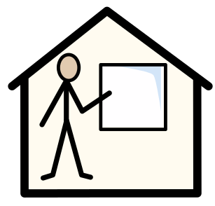 | 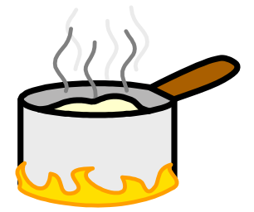 | 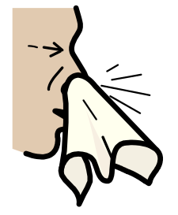
when I get to school | cooking | blowing nose
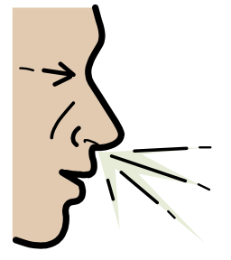 | 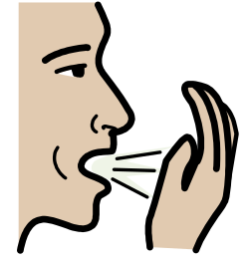
sneezing | coughing

If I feel unwell, I should tell an adult and they may think I should stay at home.
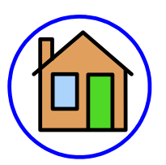
When lots of people start getting poorly, people can become afraid.

I may hear scary things at school or on TV. These things may make me feel scared, nervous or unsafe. It’s okay to feel like this.
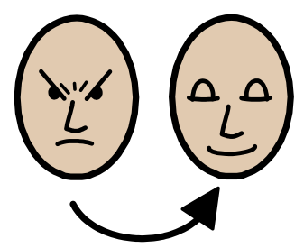
I can tell someone I trust how I am feeling. They can help me feel safe.
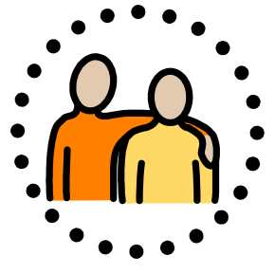
Everyone gets poorly, sometimes.
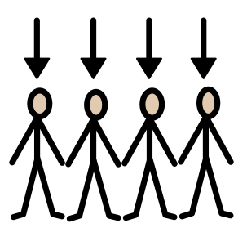
We feel poorly because our bodies are fighting the bugs.
Humans are amazing! We actually raise our own body temperature to kill the germs!

Our immune systems attack the germs and viruses and help make us better again.

We can help our immune systems stay strong, by getting enough sleep, eating healthily and washing our hands!

Coronavirus Summary:

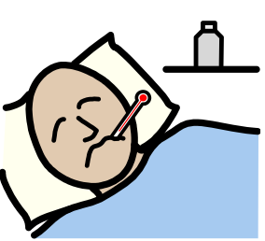 |  | 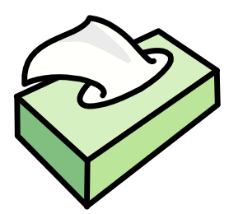
Coronavirus can make people sick. | To help stay healthy we should… | catch coughs or sneezes in a tissue
 | 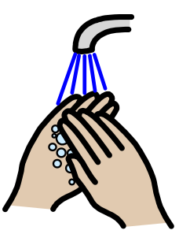
put the tissue in the bin | wash hands with soap and warm water | wash hands for 20 seconds
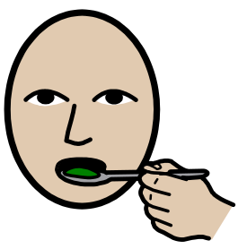 | 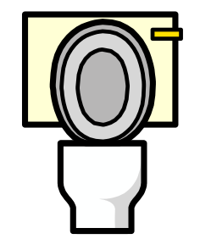
wash hands before eating | wash hands after using the toilet. | If I get poorly I will stay at home.

My guide to washing my hands:

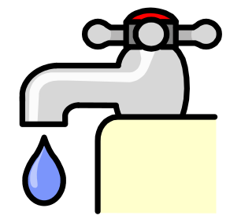 | 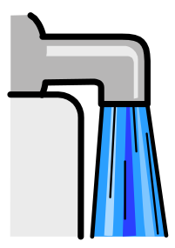 | 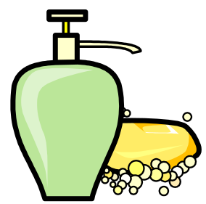
Turn on tap | Wet hands | Get soap
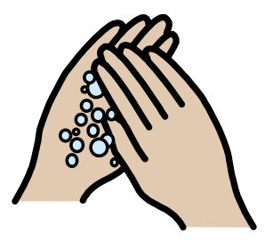 | 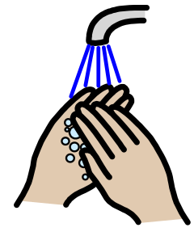 | 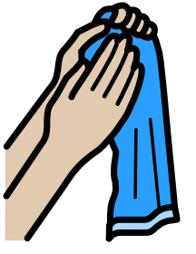
Rub hands for 20 seconds | Wash off soap | Dry hands

