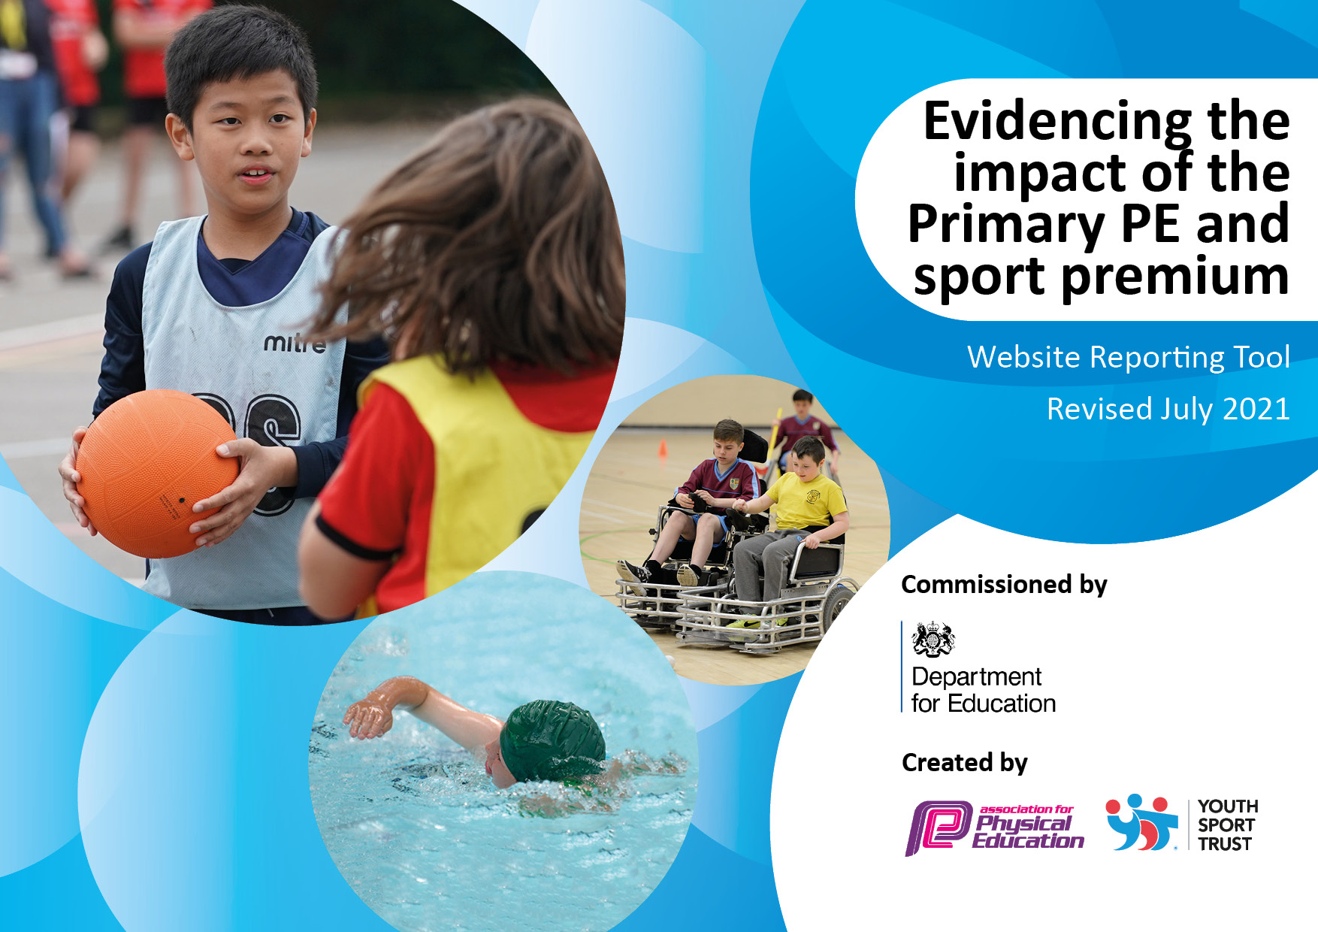

**Details with regard to funding**

Please complete the table below.

|  |  |
| --- | --- |
| Total amount allocated for 2023/24 | £ 16,000 |
| Total amount of funding for 2023/24 To be spent and reported on by 31st July 2024. | £ 16,000 |

**Swimming Data**

Please report on your Swimming Data below.

|  |  |
| --- | --- |
| What percentage of your current Year 6 cohort swim competently, confidently and proficiently over a distance of at least 25 metres? | 73% |
| What percentage of your current Year 6 cohort use a range of strokes effectively [for example, front crawl, backstroke and breaststroke]?  Please see note above | 73% |
| **What percentage of your current Year 6 cohort perform safe self-rescue in different water-based situations?** | N/A |
| Schools can choose to use the Primary PE and sport premium to provide additional provision for swimming but this must be for activity **over and above** the national curriculum requirements. Have you used it in this way? | No |

**Action Plan and Budget Tracking**

Capture your intended annual spend against the 5 key indicators. Clarify the success criteria and evidence of impact that you intend to measure to evaluate for pupils today and for the future.

|  |  |  |  |
| --- | --- | --- | --- |
| **Academic Year:** 2022/23 | **Total fund allocated:** | **Date Updated:** | |
| **Key indicator 1:** The engagement of all pupils in regular physical activity – Chief Medical Officers guidelines recommend that primary school pupils undertake at least 30 minutes of physical activity a day in school | | | |
| **Intent** | **Implementation** | | **Impact** |
| Staff confidence in delivering indoor PE to continue increasing. | Staff meeting on implementing lesson plans created in 21-22 and how they can be effectively taught.  Staff meeting to also address any concerns around teaching PE.  Employment of sports leader and appropriate deployment (PR) PR to lead PE sessions. | £10,000 | Staff continued to deliver an in-depth indoor PE curriculum, offering children a wide range of sporting opportunities, including the newly purchased New Aged Kurling kit. |
| High quality dance lessons to be delivered | PR to work with Eve Murphy (dancetoschool) to ensure Dance subject knowledge is appropriate | Paid for through the TWSSP (£2,628)  Price dependent on CPD required | Dance CPD not required due to PR’s background in dance and appropriate planning of dance lessons for KS2 children (PR swapped with CT to deliver indoor Dance unit) |
| PE resources to be up to date in preparation for the next unit | PR during the first week of each term to audit equipment for the upcoming units of learning to ensure high quality equipment is available | £2000 | Equipment replenished to ensure high quality PE units could be delivered by both the Sports leader and class teachers |
| Daily mile to be timetables and integrated within the week – Autumn term – twice a week  Spring term – increase to three times week | Physical fitness for all children  Wellbeing increases for all children |  | Daily mile track continued to be used by every child during breaks, lunches and afternoon rest breaks to increase daily activity |
| **Key indicator 2:** The profile of PESSPA being raised across the school as a tool for whole school improvement | | | |
| **Intent** | **Implementation** | | **Impact** |
| Inter-house competitions to consistently be delivered in outdoor PE | PR to schedule and plan out a house competition at the end of each outdoor unit of work contributing to house points.  Winners of each house competition to be announced in assembly. | PR to use planning time | Inter-house competitions allowed friendly competition to be delivered and ensure that conversations around winning and losing could take place. As a result, the resilience and sportsmanship of our pupils notably increased. |
| Organise a school trip to a sporting event or stadium | Contact sports clubs throughout the west midlands to see what opportunities there are for schools. | Cost dependent on trip organised | Continued partnership with Telford Tigers Ice Hockey team allowed many children to attend a game for free. |
| Achieve gold in the school games mark to continue working towards Platinum (3 out of 5 achieved) | Attend a wide range of external sporting events organised by TWSSP to expose children to new sports. | Transport - £2000 (also see transport to events in KI5) | Gold mark achieved allowed for platinum to be worked towards next year. |
| New girls football kit provided by Premier league all stars | Continuing to raise the profile of girls football in school | Free | Let girls play initiative (FA) followed and delivered, opportunities for girl’s football throughout the summer term offered. |
| Tracksuits purchased for children attending sporting competitions (R-Y6) | Increase in children’s confidence.  Motivation for children to work hard in PE.  Representation and unity. | £400 |  |

|  |  |  |  |
| --- | --- | --- | --- |
| **Key indicator 3:** Increased confidence, knowledge and skills of all staff in teaching PE and sport | | | |
| **Intent** | **Implementation** | | **Impact** |
| Staff training and confidence in delivering high quality PE | Staff training days to be attended. Training provided by TWSSP. ECT/TA CPD 26.9.23  Gynastics 12.10.23  Rounders CPD 6.3.23 – KB to attend | Paid for through the TWSSP (£2,628) | Increase in staff knowledge which also led to after school clubs being delivered due to the CPD |
| See target 1, Key indicator 1 |  |  |  |
| **Key indicator 4:** Broader experience of a range of sports and activities offered to all pupils | | | |
| **Intent** | **Implementation** | | **Impact** |
| Lunchtime sporting opportunities to be provided across a range of sports | A sporting schedule to be shared with the children in assembly with a wide range of PE activities and games on offer at lunchtimes |  | Netball noticeably popular and delivered extensively during lunchtimes which improved sporting activity and behaviour. |
| All KS2 children to have 6 weeks of swimming lessons | All KS2 children to be transported to Abraham Derby swimming pool and swimming lessons to be delivered. Trained swimming instructor (PR) to work with non-swimmers. Badges to be purchased and provided to all children at the end of the unit | Transport -  £110 per day  Y3/4 – 6 sessions = £660  Y5/6 – 6 sessions = £660  Badges - £600 | Decrease in the amount of non-swimmers throughout KS2. |

|  |  |  |  |
| --- | --- | --- | --- |
| **Key indicator 5:** Increased participation in competitive sport | | | |
|
| **Intent** | **Implementation** | | **Impact** |
| Transport to external competitions | Money allocated to ensure all children have the opportunity to participate in competitive sport organised by TWSSP and competitions with local school | £3000 | Allowed opportunities for many students to compete against other schools – Also led to the school coming second in the county for Girl’s Sports hall Athletics and County champions in Archery! |

|  |  |
| --- | --- |
| Signed off by | |
| Head Teacher: | Tammy Lockley |
| Date: | September 2024 |
| Subject Leader: | Robbie Evans |
| Date: | September 2024 |
| Governor: | Emma Williams |
| Date: | September 2024 |