

Special Educational Needs and Disabilities (SEND) Policy

Audience: | REAch2 staff  Local Governing Bodies  Cluster Boards  Trustees  Local Authorities  Parents
Ratified: | REAch2 Trust Board  March 2024
Other related policies: | - Admissions Policy  - Pupil Equality, Equity, Diversity and Inclusion Policy  - Pupil Confidentiality Policy  - Data Protection Policy  - Records Management Policy  - Social, Emotional and Mental Health (SEMH) Policy  - Supporting Pupils with Medical Conditions Policy  - Child Protection and Safeguarding Policy  - Physical Intervention Policy  - Careers Policy  - Suspension and Exclusion Policy  - Behaviour Policy  - Complaints Procedures Policy  - Accessibility Policy
Policy owner: | Rachael Stevenson – Head of SEND
Review: | Every two years

At REAch2, our actions and our intentions as school leaders are guided by our Touchstones.

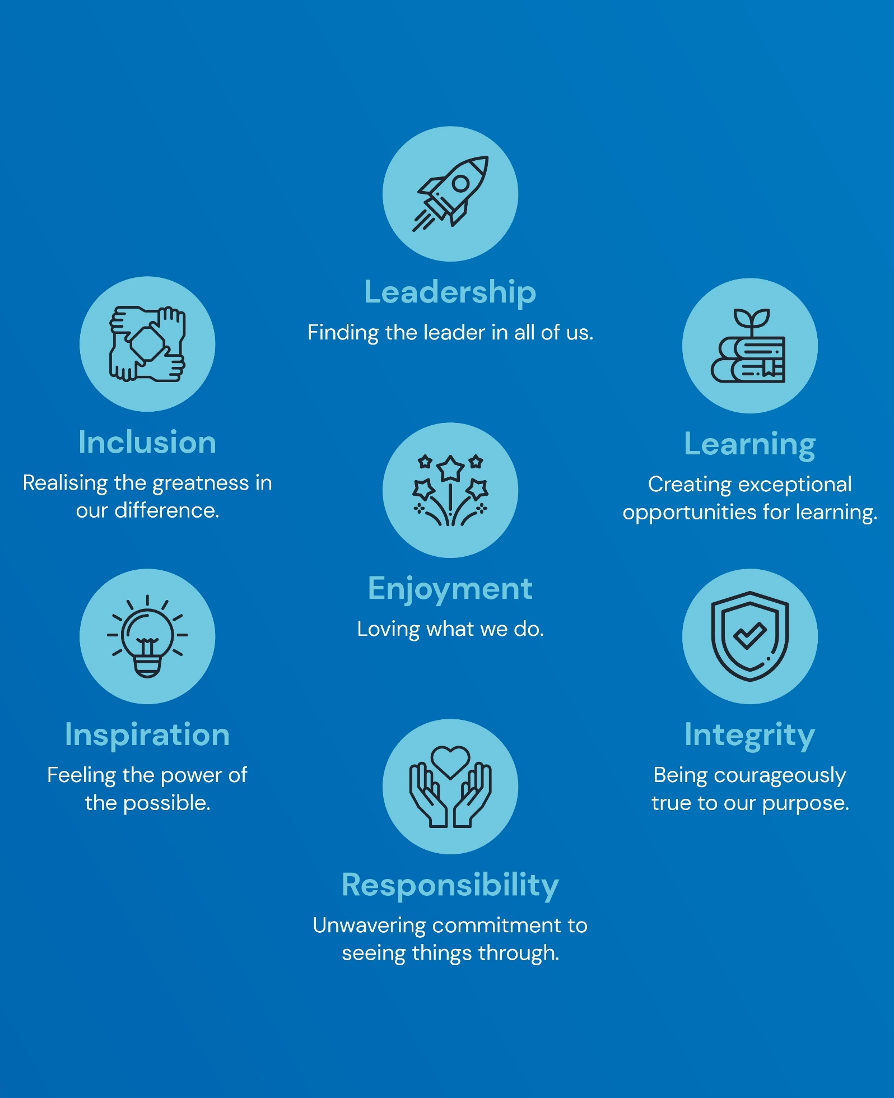

Contents:
Statement of intent
- Legal framework
- Objectives
- Roles and responsibilities
- Identifying SEND
- Safeguarding
- SEND support
- Admissions
- Transition
- Involving pupils and parents in decision-making
- Funding for SEND support
- EHC needs assessments and plans
- Reviewing EHC plans
- Supporting successful preparation for adulthood
- Managing complaints
- Staff training and improving practice
- Use of data and record keeping
- Publishing information
- Joint commissioning, planning and delivery
- Behaviour – Suspensions and Permanent Exclusions
- Local Offer
Appendices

Statement of intent
As part of REAch2 Academy Trust, Aqueduct Primary Academy believes that all pupils are entitled to an education that enables them to achieve their best, become confident individuals living fulfilling lives, and make a successful transition into adulthood.
This policy outlines the framework the school will use in meeting its duties, obligations and principal equality values in providing an appropriate high-quality education for pupils with SEND.
Through successful implementation of this policy, the school aims to eliminate discrimination and promote equal opportunities.
The school will work with the LA, or equivalent, in ensuring that the following principles underpin this policy:
- The involvement of pupils and their parents in decision-making.
- The early identification of pupils’ needs and early intervention to support them.
- A focus on inclusive practice and removing barriers to learning.
- Collaboration between education, health and social care services to provide support.
- High-quality provision to meet the needs of pupils with SEND.
- Greater choice and control for pupils and their parents over their support.
- Successful preparation for adulthood, including independent living and employment.
Under the Equality Act 2010, a disability is a physical or mental impairment which has a long-term and substantial adverse effect on a person’s ability to carry out normal day-to-day activities. For the purposes of this policy, a pupil is defined as having SEND if they have:
- A significantly greater difficulty in learning than most others of the same age.
- A disability or health condition that prevents or hinders them from making use of educational facilities used by peers of the same age in mainstream settings.
- Special educational provision that is additional to or different from that made generally for other children or young people of the same age by mainstream settings.

Legal framework
This policy has due regard to all relevant legislation including, but not limited to, the following:
- Local Government Act 1974
- Disabled Persons (Services, Consultation and Representation) Act 1986
- Children Act 1989
- Education Act 1996
- Education Act 2002
- Mental Capacity Act 2005
- Equality Act 2010
- The Equality Act 2010 (Disability) Regulations 2010
- Children and Families Act 2014
- The Special Educational Needs (Personal Budgets) Regulations 2014
- The Special Educational Needs and Disability (Amendment) Regulations 2015
- The Special Educational Needs and Disability (Detained Persons) Regulations 2015
- The UK General Data Protection Regulation (GDPR)
- Data Protection Act 2018
- Health and Care Act 2022
This policy has due regard to statutory and non-statutory guidance, including, but not limited to, the following most recent guidance:
- DfE ‘Special educational needs and disability code of practice: 0 to 25 years’
- DfE ‘Supporting pupils at school with medical conditions’
- DfE ‘Working Together to Safeguard Children’
- DfE ‘Mental health and wellbeing provision in schools’
- DfE ‘School Admissions Code’
- DfE ‘Keeping children safe in education’
- Equality and Human Rights Commission ‘Reasonable adjustments for disabled pupils’
This policy operates in conjunction with any of the following school policies:
- Admissions Policy
- Pupil Equality, Equity, Diversity and Inclusion Policy
- Pupil Confidentiality Policy
- Data Protection Policy
- Records Management Policy
- Social, Emotional and Mental Health (SEMH) Policy
- Supporting Pupils with Medical Conditions Policy
- Child Protection and Safeguarding Policy
- Physical Intervention Policy
- Careers Policy
- Suspension and Exclusion Policy
- Behaviour Policy
- Complaints Procedures Policy
- Accessibility Policy

Objectives
Every school is required to identify and address the SEND of the pupils that they support. Through the implementation of this policy, the school will:
- Use their best endeavours to make sure that pupils with SEND get the support they need to access the school’s broad and balanced curriculum.
- Ensure that pupils with SEND engage in the activities of the school alongside pupils who do not have SEND.
- Ensure there is high-quality provision to meet the needs of pupils with SEND, with specific focus on inclusive practice and removing barriers to learning.
- Fulfil its statutory duties towards pupils with SEND in light of the SEND code of practice.
- Promote disability equality and equality of opportunity, fulfilling its duties under the Equality Act 2010 towards individual disabled pupils.
- Make reasonable adjustments, including the provision of auxiliary aids and services, to ensure that disabled pupils are not at a substantial disadvantage compared with their peers.
- Designate a teacher to be responsible for coordinating SEND provision, i.e. the SENCO.
- Inform parents when they are making special educational provision for their child.
- Review, prepare and publish important information about the school and its implementation of relevant SEND policies, including:
  - Accessibility plans setting out how they plan to increase access to the curriculum and the physical environment for pupils with SEND.
  - Information about the admission arrangements for pupils with SEND and the steps taken to prevent them being treated less favourably than others.
  - A SEN information report about the implementation of the school’s policy for pupils with SEND.

Roles and responsibilities
The governing board will be responsible for:
- Ensuring this policy is implemented fairly and consistently across the school.
- Ensuring the school meets its duties in relation to supporting pupils with SEND.
- Ensuring that there is a qualified teacher designated as SENCO for the school.
The headteacher is responsible for ensuring the school offers a broad and balanced curriculum, with high quality teaching and a positive and enriching educational experience of for all pupils, including pupils with SEND.
In enacting this policy, the headteacher will:
- Ensure the school holds ambitious expectations for all pupils with SEND.
- Establish and sustain culture and practices that enable pupils with SEND to access the curriculum and learn effectively.
- Ensure the school works effectively in partnership with parents, carers and professionals, to identify the additional needs and SEND of pupils, providing support and adaptation where appropriate.
- Ensure the school fulfils its statutory duties with regard to the SEND code of practice.
- Work with the governing board to ensure that there is a qualified teacher designated as SENCO for the school.
- Ensure the SENCO has sufficient time and resources to carry out their functions.
- Provide the SENCO with sufficient administrative support and time away from teaching to enable them to fulfil their responsibilities.
- Regularly and carefully reviewing the quality of teaching for pupils at risk of underachievement, as a core part of the school’s performance management arrangements.
- Ensure that procedures and policies for the day-to-day running of the school do not directly or indirectly discriminate against pupils with SEND.
The SENCO will be responsible for:
- Collaborating with the governing board and headteacher, to determine the strategic development of the SEND policy and provision in the school.
- The day-to-day responsibility for the operation of SEND policy.
- The coordination of specific provision made to support individual pupils with SEND.
- Liaising with the relevant designated teacher for LAC with SEND.
- Advising on a graduated approach to providing SEND support.
- Advising on the deployment of the school’s delegated budget and other resources to meet pupils’ needs effectively.
- Liaising with the parents of pupils with SEND.
- Liaising with early years providers, other schools, educational psychologists, health and social care professionals, and independent or voluntary bodies, as required.
- Being a key point of contact for external agencies, especially the LA and LA support services.
- Liaising with the potential future providers of education to ensure that pupils and their parents are informed about the options, and a smooth transition is planned.
- Working with the relevant governors and the headteacher to ensure that the school meets its responsibilities under the Equality Act 2010, regarding reasonable adjustments and access arrangements.
- Ensuring that the school keeps the records of all pupils with SEND up-to-date, in line with the school’s Data Protection Policy.
- Providing professional guidance to colleagues, and working closely with staff, parents and other agencies.
- Being familiar with the provision in the Local Offer and being able to work with professionals who are providing a supporting role to the family.
Teachers will be responsible for:
- Planning and reviewing support for pupils with SEND on a graduated basis, in collaboration with parents, the SENCO and, where appropriate, the pupils themselves.
- Setting high expectations for every pupil and aiming to teach them the full curriculum, whatever their prior attainment.
- Planning lessons to address potential areas of difficulty to ensure that there are no barriers to every pupil achieving.
- Ensuring every pupil with SEND is able to study the full national curriculum.
- Being accountable for the progress and development of the pupils in their class.
- Being aware of the needs, outcomes sought, and support provided to any pupils with SEND they are working with.
- Understanding and implementing strategies to identify and support vulnerable pupils with the support of the SENCO.
- Keeping the relevant figures of authority up-to-date with any changes in behaviour, academic developments and causes of concern. The relevant figures of authority include the headteacher.
- Work with others adults in school to effectively support all children to ensure they make progress.

Identifying SEND
The school recognises that early identification and effective provision improves long-term outcomes for pupils. As part of the overall approach to monitoring the progress and development of all pupils, it has a clear approach to identifying and responding to SEND (Appendix A – Identification Process – Assess, Plan, Do, Review) as outlined in the school’s SEN Information Report. (Appendix B – Request for SENCO observation Form)
With the support of the SLT, classroom teachers will conduct regular progress assessments for all pupils, with the aim of identifying pupils who are making less than expected progress given their age and individual circumstances despite a range of quality first teaching strategies consistently implemented for a period of time.
‘Less than expected progress’ will be characterised by progress which:
- Is significantly slower than that of their peers starting from the same baseline.
- Does not match or better the pupil’s previous rate of progress.
- Fails to close the attainment gap between them and their peers.
- Widens the attainment gap.
The final decision as to whether the child joins the send register is when; they require different or additional to what is universally available or has a disability which prevents or hinders them from making use of the facilities in school.
The school plans, manages and reviews SEND provision across the following four broad areas of need:
- Communication and interaction
- Cognition and learning
- Social, emotional and mental health difficulties
- Sensory and/or physical needs

All children on the SEND register need to be accurately recorded on Arbor. Arbor is where the school’s SEND register must be kept. (Appendix C – How to Use Arbor for SEND adding SEND, running SEND lists, SEND statistics)

Safeguarding
The school recognises that evidence shows pupils with SEND are at a greater risk of abuse and maltreatment, so will ensure that staff are aware that pupils with SEND:
- Have the potential to be disproportionately impacted by behaviours such as bullying.
- May face additional risks online, e.g. from online bullying, grooming and radicalisation.
- Are at greater risk of abuse, including child-on-child abuse, neglect, and sexual violence and harassment.
The school recognises that there are additional barriers to recognising abuse and neglect in this group of pupils. These barriers can include, but are not limited to:
- Assumptions that indicators of possible abuse such as behaviour, mood and injury relate to the pupil’s condition without further exploration.
- These pupils being more prone to peer group isolation or bullying (including prejudice-based bullying) than other pupils.
- The potential for pupils with SEND or certain medical conditions being disproportionally impacted by behaviours such as bullying, without outwardly showing any signs.
- Communication barriers and difficulties in managing or reporting these challenges.
- A different cognitive understanding and being unable to understand the difference between fact or fiction in online content.
The headteacher and governing board will ensure that the school’s Child Protection and Safeguarding Policy reflects the fact that these additional barriers can exist when identifying abuse. When using physical intervention and reasonable force in response to risks presented by incidents involving pupils with SEND, staff will have due regard for the procedures outlined in the school’s Physical Intervention Policy.
Care will be taken by all staff, particularly those who work closely with pupils with SEND, to notice any changes behaviour or mood, or any injuries, and these indicators will be investigated by the DSL in collaboration with the SENCO.
School staff will be particularly alert to the potential need for early help for pupils with SEND and additional needs.
The governing board and headteacher will ensure that pupils with SEND are taught about how to keep themselves and others safe including online. The school will ensure that teaching of safeguarding is tailored to the specific needs and vulnerabilities of pupils with SEND.
Any reports of abuse involving pupils with SEND will involve close liaison between the DSL and the SENCO.

SEND support (K Code)
The school is aware of its statutory duty to provide a broad and balanced curriculum and recognise that high quality teaching, which is adapted for individual pupils, is the first step in responding to pupils who have or may have SEND.
Teachers at the school will:
- Set high expectations for every pupil.
- Plan stretching work for pupils whose attainment is significantly above the expected standard.
- Plan lessons for pupils who have low levels of prior attainment or come from disadvantaged backgrounds.
- Use appropriate assessment to set targets which are deliberately ambitious.
- Plan lessons to ensure that there are no barriers to every pupil achieving.
- Be responsible and accountable for the progress and development of the pupils in their class, including where pupils access support from teaching assistants or specialist staff.
Decisions on whether to make special educational provision for pupils will be based upon:
- Discussions between the teacher and SENCO.
- Analysis of the pupil’s progress – using internal formative and summative assessments, alongside national data and expectations of progress.
- Observations of the child.
- Discussion with the pupil and their parent.
Once a pupil has been identified with SEND, the school will employ a graduated approach to meeting the pupil’s needs. This will be through the adoption of a four-part cycle – assess, plan, do, review – whereby earlier decisions and actions are revisited, refined and revised with a growing understanding of the pupil’s needs and of what supports the pupil in making good progress and securing good outcomes. This will be documented using the school’s SEND Support Plan (Pre-teach / Intervention provision map). The process is as follows:
- Assess: establishing a clear assessment of the pupil’s needs
- Plan: agreeing the adjustments, interventions and support to be put in place, as well as the expected impact on progress, development or behaviour, along with a clear date for review
- Do: implementing the agreed interventions and support
- Review: analysing the effectiveness of the interventions and their impact on the pupil’s progress in line with the agreed review date
Where higher levels of need are identified, the school will access specialised assessments from external agencies and professionals.
Where, despite the school having taken relevant and purposeful action to identify, assess and meet the SEN of a pupil, they have not made expected progress, the school, in consultation with parents, will consider requesting an Education, Health and Care needs assessment. Parents are also have a right to apply for an Education, Health and Care needs assessment and details of how to complete this request can be found on the Local Authorities Local Offer. https://www.telfordsend.org.uk/site/index.php
The school will consider whether additional pastoral support and attention for pupils with SEND is required, alongside ensuring that any appropriate support for communication is in place.

EAL
The school is aware that there may be pupils at the school for whom English is not their first language and appreciates that having EAL is not equated to having learning difficulties. At the same time, when pupils with EAL make slow progress, it will not be assumed that their language status is the only reason; they may have SEND.
The school will consider the pupil within the context of their home, culture and community and look carefully at all aspects of a pupil’s performance in different subjects to establish whether the problems they have in the classroom are due to limitations in their command of English or arise from SEND.

Admissions
The school will ensure it meets its duties set under the DfE’s ‘School Admissions Code’ by:
- Not refusing admission for a child thought to be potentially disruptive, or likely to exhibit challenging behaviour, on the grounds that the child is first to be assessed for SEND.
- Not refusing admission for a child that has named the school in their EHC plan.
- Considering applications from parents of children who have SEND but do not have an EHC plan.
- Not refusing admission for a child who has SEND but does not have an EHC plan because the school does not feel able to cater for those needs.
- Not refusing admission for a child who does not have an EHC plan.
- Not discriminating against or disadvantaging applicants with SEND.
- Health and safety risk assessments may need to be carried out as part of the admissions process.
- Ensuring policies relating to school uniform and trips do not discourage parents of pupils with SEND from applying for a place.
- Adopting fair practices and arrangements in accordance with the ‘School Admissions Code’ for the admission of children without an EHC plan.
- Ensuring the school’s oversubscription arrangements will not disadvantage children with SEND.
- Ensuring that tests for selection are accessible to children with SEND, with reasonable adjustments made where necessary.

Arrangements for the fair admissions of pupils with SEND are outlined in the Admissions Policy and will be published on the school website.

Transition
The school is aware of the importance of planning and preparing for the transitions between phases of education and preparation for adult life. The school will take the following action:
Where children are joining the school in EYFS:
- Pupils due to join our reception class receive a visit at their pre-school/nursery/home setting from the EYFS lead. The children visit the school/classroom prior to starting and meet with staff. Where a child already has identified special educational needs, the SENCo will also visit the child in their pre-school setting. The SENCo and/or Reception class staff will attend pre-school TAC meetings prior to a child with SEND attending school if appropriate. If suitable a child may be encouraged to visit their new setting multiple times.

When pupils are moving within the school (end of year transition) :
- Prior to the start of a new academic year, class teachers and LSAs receive information about the SEND children in their class, including their Assess, Plan, Do, Review (APDR) and One Page Profile. Relevant training/courses is arranged for teachers/LSAs as needed.
- In the Summer term prior to the new academic year transition mornings take place to meet the new teacher and class. If suitable a child may also be encouraged to briefly visit their new teacher multiple times to become more familiar with their new teacher, classroom.

When pupils move on to another school:
- All children with SEND can visit the school and have a tour prior to starting to familiarise themselves with the staff, school structure, and main sites including toilets, hall, playground etc.
- We have a highly skilled pastoral team to monitor well-being and Playground Pals to help children make new friends.
- All school SEND records are passed on to any other school a child transfers to.

Transition to secondary school:
- Staff at Aqueduct Academy endeavour to communicate with the SENCo of any Secondary School due to receive any of our SEND pupils to discuss the specific needs of the child. Families are always included in any meetings, as are the teacher, SENCo and child.
- Where possible your child will visit their new school on several occasions and in some cases staff from the new school will visit your child here at Aqueduct.

Where pupils have EHC plans, these will be reviewed and amended in sufficient time prior to a pupil moving between key phases of education, (Code Of Practice 9.179) to allow for planning for and, where necessary, commissioning of support and provision at the new setting.

Involving pupils and parents in decision-making
The school is committed to working in partnership with all parents in the best interests of their child and will provide an annual report for all parents on their child’s progress.
Where a pupil is receiving SEND support, the school will regularly liaise with parents in setting outcomes and reviewing progress (graduated response process). The class teacher will meet with the parents in the autumn and spring term. There is also the opportunity for parents of children with SEND to meet with the class teacher following the distribution of the end of year reports each year. Where required, the SENCo will support and attend meetings.
The planning that the school implements will help parents and pupils with SEND express their needs, wishes and goals, and will:
- Focus on the pupil as an individual, not allowing their SEND to become a label.
- Be easy for pupils and their parents to understand by using clear, ordinary language and images, rather than professional jargon.
- Highlight the pupil’s strengths and capabilities.
- Enable the pupil, and those who know them best, to say what they have done, what they are interested in and what outcomes they are seeking in the future.
- Tailor support to the needs of the individual.
- Organise assessments where possible and complete relevant referrals alongside parents.
- Bring together relevant professionals to discuss and agree together the overall approach.
Where the LA provides a pupil with an EHC plan, the school will involve the parents and the pupil in discussions surrounding how the school can best implement the plan’s provisions to help the pupil thrive in their education and will discern the expected impact of the provision on the pupil’s progress.
Where necessary, the school will facilitate support from an advocate to ensure the parent’s views are heard and acknowledged.

Funding for SEND support
Where additional pupil needs are identified the school will use its delegated funding allowance to provide early intervention support for the benefit of pupils identified with SEND.
Where pupils with SEND have been receiving early intervention support but are still not making sufficient progress, the school will consider accessing high needs top-up funding from the LA to provide additional specialist support.

EHC needs assessments and plans
The school recognises that, despite having taken relevant and purposeful action to identify, assess and meet the SEND of a pupil, some pupils may not make expected levels of progress. In these cases, where the graduated response has been implemented for a period of time, the school will consult with parents and consider requesting an EHC needs assessment.
The purpose of an EHC plan is to make special educational provision to meet the SEND of the pupil, to secure the best possible outcomes for them across education, health and social care and prepare them for adulthood.
As part of the EHC needs assessment, the school will meet its duty by:
- Responding to any request for information as part of the EHC needs assessment process within six weeks from the date of the request, unless special exemptions apply as outlined in the SEND code of practice.
- Providing the LA with any school-specific information and evidence about the pupil’s profile and educational progress.
- Gathering any advice received from relevant professionals regarding their education, health and care needs, desired outcomes, and any special education, health and care provision that may be required to meet their identified needs and achieve desired outcomes.
If, following the assessment, the LA decides not to issue an EHC plan, the school will be provided with written feedback collected during the EHC needs. It will use this information to contribute to the graduated approach and inform how the outcomes sought for the pupil can be achieved through further special educational provision made by the school and its partners.
Parents have a legal write to appeal against the decision. Information on how to appeal should be in the parents letter or can be found here: (SEND - Local offer https://www.telfordsend.org.uk/site/index.php), (Telford SENDIASS | SENDIASS Telford https://www.telfordsendiass.org.uk/ ) and Appealing to the SEND tribunal (ipsea.org.uk)
Where the LA decides to issue an EHC plan, it must consult the prospective school by sending a copy of the draft plan and consider their comments before deciding whether to name it in the pupil’s EHC plan. The school will meet its duty to provide views on a draft EHC plan within 15 days.
The school will admit any pupil that names the school in an EHC plan and will ensure that all those teaching or working with a pupil named in an EHC plan are aware of the pupil’s needs and that arrangements are in place to meet them.

Reviewing EHC plans
The school will ensure that teachers monitor and review the pupil’s progress during the year and conduct a formal review of the EHC plan at least annually.
The school will:
- Cooperate with the LA and relevant individuals to ensure an annual review meeting takes place, including convening the meeting on behalf of the LA if requested.
- Ensure that the appropriate people are given at least two weeks’ notice of the date of the meeting, such as representatives from the LA SEN, social care and health services.
- Seek advice and information about the pupil prior to the annual review meeting from all parties invited, and send any information gathered to all those invited, at least two weeks in advance of the meeting.
- Ensure that sufficient arrangements are put in place at the school to host the annual review meeting.
- Contribute any relevant information and recommendations about the EHC plan to the LA, keeping parents involved at all times.
- Lead the review of the EHC plan to create the greatest confidence amongst pupils and their parents.
- Prepare and send a report of the meeting to everyone invited within two weeks of the meeting, setting out any recommendations and amendments to the EHC plan.
- Clarify to the parents and pupil that they have the right to appeal the decisions made regarding the EHC plan.
- Where possible for LAC, combine the annual review with one of the reviews in their care plan, in particular the personal education plan (PEP) element.
- Where necessary, provide support from an advocate to ensure the pupil’s views are heard and acknowledged.
- Where necessary, facilitate support from an advocate to ensure the parent’s views are heard and acknowledged.
- Review each pupil’s EHC plan to ensure that it includes the statutory sections outlined in the ‘Special educational needs and disability code of practice: 0 to 25 years’, labelled separately from one another.
If a pupil’s needs significantly change, the school will request a re-assessment of an EHC plan at least six months after an initial assessment. Thereafter, the governing board or headteacher will request the LA to conduct a re-assessment of a pupil whenever they feel it is necessary.

Supporting successful preparation for adulthood
The school is aware that being supported towards greater independence and employability can be life-transforming for pupils with SEND. It recognises the importance of starting early, centring on pupil aspirations, interests and needs, and will ensure that pupils are supported at developmentally appropriate levels to make a smooth transition to what they will be doing next, e.g. moving on to higher education.
The school will:
- Seek to understand the interests, strengths and motivations of pupils and use this as a basis for planning support around them.
- Support pupils so that they are included in social groups and develop friendships.
- Ensure that pupils with SEND engage in the activities of the school together with those who do not have SEND, and are encouraged to participate fully in the life of the school and in any wider community activity.
- Engage with secondary schools, as necessary, to help plan for any transitions.
The school’s Careers Policy details how the school will fulfil its statutory duties under section 42 of the Education Act 1997 and work with pupils with SEND to ensure they are prepared for the workplace.

Managing complaints
The school will publish the Complaints Procedure Policy on the school website.
Following a parent’s serious complaint or disagreement about the SEND provision being made for their child, the school will contact the LA immediately to seek disagreement resolution advice, regardless of whether an EHC plan is in place.
The school is aware of the formal and informal arrangements for resolving disagreements at a local level and will work with the LA in responding to requests for information as part of procedures for:
- Disagreement resolution.
- Mediation.
- Appeals to the SEND Tribunal.
Support for parents can be through IASS (Telford SENDIASS | SENDIASS Telford https://www.telfordsendiass.org.uk/)
Parents will be made aware that Ofsted can consider complaints relating to whole-school SEND early years provision if the problem has not been resolved informally.
The school will meet any request to attend a SEND tribunal and explain any departure from its duties and obligations under the ‘Special educational needs and disability code of practice: 0 to 25 years’.

Staff training and improving practice
The school is committed to the learning and development of all its staff members and training opportunities will be provided and delivered in line with the school’s CPD and Training Policy.
The school SENCO will assess staff competencies and ensure that CPD provision allows staff to develop their awareness, skills, and practices in identifying, educating, and assessing pupils with SEND.

Use of data and record keeping
All information about pupils will be kept in accordance with the school’s Records Management Policy and Data Protection Policy.
The school’s records will:
- Record details of additional or different provision made under SEND support, with accurate information to evidence the SEND support that has been provided over the pupil’s time in the school, as well as its impact, e.g. through the use of provision maps.
- Include details of SEND, outcomes, action, agreed support, teaching strategies and the involvement of specialists, as part of its standard management information system to monitor the progress, behaviour and development of all pupils.
- Maintain an accurate and up-to-date register of the provision made for pupils with SEND.
- Be kept securely so that unauthorised persons do not have access to it, so far as reasonably practicable.
The school keeps data on the levels and types of need within the school and makes this available to the LA and Ofsted.
Confidentiality
The school will not disclose any EHC plan without the consent of the pupil’s parents, except for specified purposes or in the interests of the pupil, such as disclosure:
- To a SEND tribunal when parents appeal, and to the Secretary of State under the Education Act 1996.
- On the order of any court for any criminal proceedings.
- For the purposes of investigations of maladministration under the Local Government Act 1974.
- To enable any authority to perform duties arising from the Disabled Persons (Services, Consultation and Representation) Act 1986, or from the Children Act 1989 relating to safeguarding and promoting the welfare of children.
- To Ofsted inspection teams as part of their inspections of schools and LAs.
- To any person in connection with the pupil’s application for students with disabilities allowance in advance of taking up a place in HE.
- To the headteacher (or equivalent position) of the setting at which the pupil is intending to start their next phase of education.
The school will adhere to the Pupil Confidentiality Policy at all times.

Publishing information
The school will publish information on the school website about the implementation of this policy.
The information published will be updated annually and any changes to the information occurring during the year will be updated as soon as possible.
The SEN Information Report will be prepared by the school and will be published on the school website. It will include all the information outlined in paragraphs 6.79 and 6.83 of the ‘Special educational needs and disabilities code of practice: 0 to 25 years’.
Our School’s Information Report can be found here: (Aqueduct Primary Academy https://www.aqueductprimary.co.uk/)

Joint commissioning, planning and delivery
The school will work closely with local education, health and social care services to ensure pupils get the right support.
The school will assist the LA in carrying out their statutory duties under the Children and Families Act 2014, by ensuring that services work together where this promotes children and young people’s wellbeing or improves the quality of special educational provision (Section 25 of the Children and Families Act 2014).
The school will draw on the wide range of local data sets about the likely educational needs of pupils with SEND to forecast future needs, including:
- Population and demographic data.
- Prevalence data for different kinds of SEND among children at the national level.
- Numbers of local children with EHC plans and their main needs.
- The numbers and types of settings locally that work with or educate pupils with SEND.
- An analysis of local challenges or sources of health inequalities.
The school will plan, deliver and monitor services against how well outcomes have been met, including, but not limited to:
- Improved educational progress and outcomes for pupils with SEND.
- Increasing the identification of pupils with SEND prior to school entry.
Where pupils with SEND also have a medical condition, their provision will be planned and delivered in coordination with the EHC plan.
SEND support will be adapted and/or replaced depending on its effectiveness in achieving the agreed outcomes.

Behaviour – Suspensions and Permanent Exclusions
The law does not prevent a pupil with SEND from being suspended or permanently excluded. However, schools do have a legal duty under the Equality Act 2010 not to discriminate against a pupil by suspending or permanently excluding them from school because of their disability and reasonable adjustments may need to be made.
Suspensions and Permanent Exclusion are only ever to be used as a last resort and before Headteacher’s make the decisions to suspend or permanently exclude a child with SEND they must feel assured the sanction is fair and lawful and the individual child’s provisions to meet their need, are in place, and all other strategies and support has been utilised to avoid the suspension or permanent exclusion.
Reasonable adaptations to School’s Behaviour Policies for SEND children will need to be made depending on their SEND needs; whilst still maintaining the safety of the child, other children and staff. These adaptations should be recorded in the child’s SEND Support Plan and/or (School specific documents may also be used, e.g. Risk Reduction Plan, behaviour support plan). If a child has an EHCP these should also form part of the child’s Section F provision, if needs have changed an early EHCP review will be called with parents and the Local Authority.
Pupils can only be excluded for disciplinary reasons, Children with SEND cannot be excluded because the school is unable meet their needs or for something which their parents did or did not do. The school cannot use ‘Informal’ or ‘unofficial’ exclusions/suspensions, such as sending a pupil home to cool off, as these are unlawful even if a parent or carer agrees to it.

Local Offer
The school’s governing board will collaborate with and support the LA in developing and reviewing the Local Offer, where necessary and appropriate, to ensure that it is:
- Collaborative: Where appropriate, the school will work with LAs, parents and pupils in developing and reviewing the Local Offer. The school will also cooperate with those providing services.
- Accessible: The school will collaborate with the LA during development and review to ensure that the LA’s Local Offer is easy to understand, factual and jargon-free; is structured in a way that relates to pupils’ and parents’ needs, e.g. by broad age group or type of special educational provision; and is well-signposted and -publicised.
- Comprehensive: The school will help to ensure that parents and pupils understand what support can be expected to be available across education, health and social care from age 0 to 25 and how to access it. The school will assist the LA in ensuring that the Local Offer includes eligibility criteria for services, where relevant, and makes it clear where to go for information, advice and support, as well as how to make complaints about provision or appeal against decisions.
- Up-to-date: The school will work with the LA to review the Local Offer to ensure that, when parents and pupils access the Local Offer, the information is up-to-date.
The school will provide the LA with information about their existing SEND provision and capabilities to support pupils with SEND to aid in the drafting of the Local Offer, where required.
Our Local Authorities Local Offer can be found here: SEND - Local offer https://www.telfordsend.org.uk/site/index.php
Appendix A – SEND Identification Process (Assess, Plan, Do, Review)
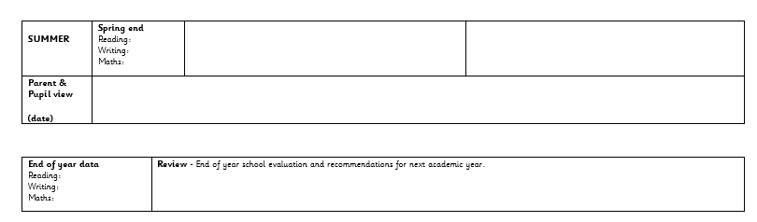
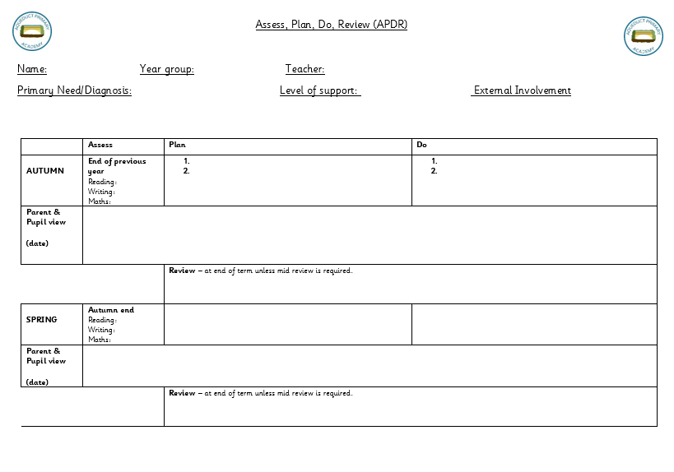

Appendix B – Request for SENCO observation

SEND concerns - Internal Referral Form
Record of Concern/Monitoring Stage

Name of Pupil |  |  |  |  | DOB (Age)
Class |  |  |  |  | Year Group
Start Date of Referral |  |  | Name of referrer and role
Does/ is the child currently on the SEN list/ EHCP/ other support? |  |  |  | Intervention

Please tick which area(s) are a concern:
*Communication and interaction (Speech and Language, Autistic Spectrum Disorders)
*Cognition and learning (Specific Learning Difficulties, General Learning Difficulties)
*Social, emotional and mental health difficulties
*Sensory and/or physical difficulties (Hearing or Visual impairment, Physical or medical needs)
I have the following concerns (please be as detailed as possible with examples/evidence):

Parental views:

Signed: _________________________________________ Date : _____________________________
Pupil view:

Date: ___________________________
This is what I have done to date to support them so far: (Add anything that you have done yourself in class to support the child.)
Strategies (date started/ended) | Impact
Any other relevant information? (Please attach any documents you think might be helpful, have you had discussions with parents, is there any background or circumstantial information that might be useful?)

SEND concern form passed to SENCO via email : (Add date)
Actions taken by SENCO (dated):
Observations/discussion note by SENCO-

Appendix C – How to Use Arbor for SEND: adding SEND status and needs, SEND Register, SENDS statistics

How to add SEND Status to a child:

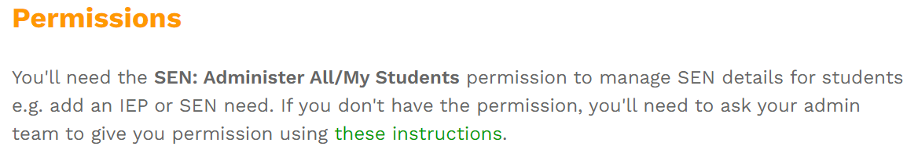

Search child here, along to top right.

Once in the child’s area, go to ‘Educational Needs’ on the left side.
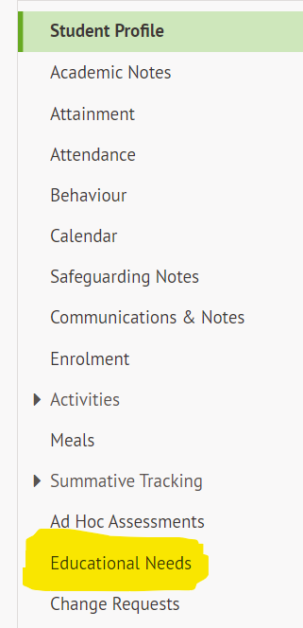

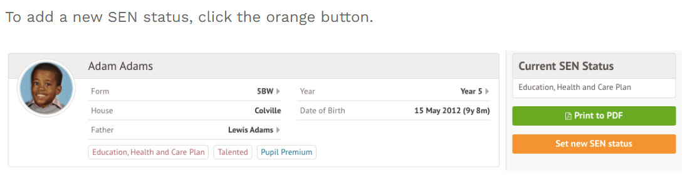

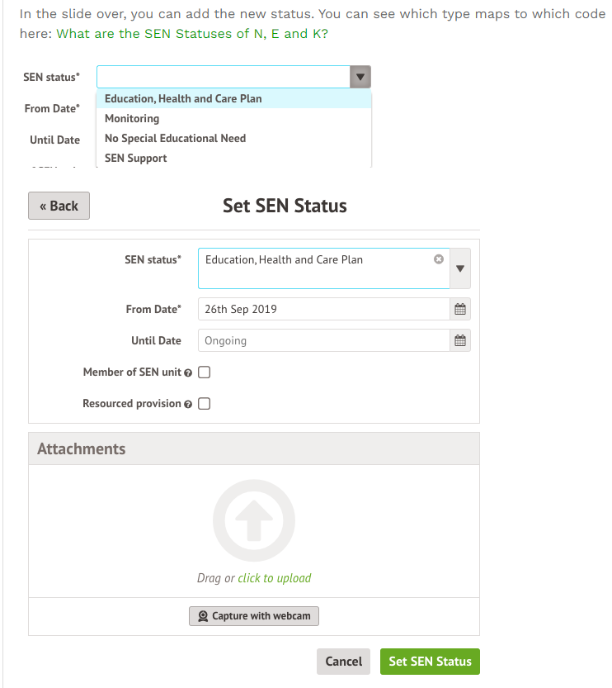

To move a child from SEND Support to EHCP you will need to end the SEND Support the day before the EHCP status is set.

How to add a Need to a child:

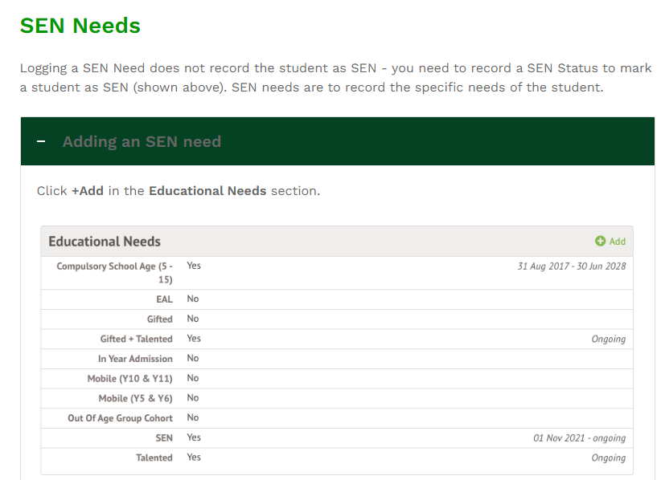

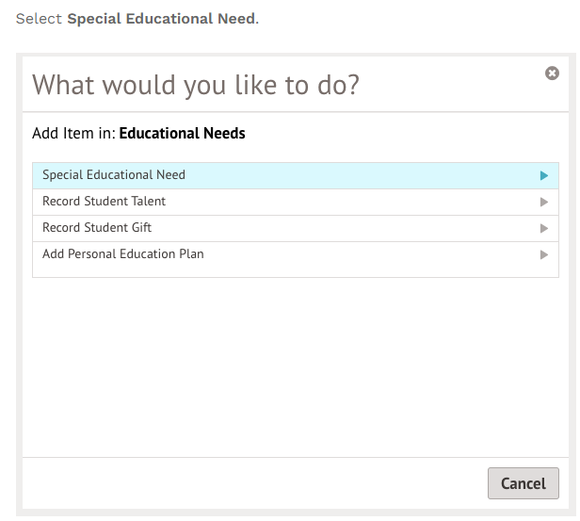

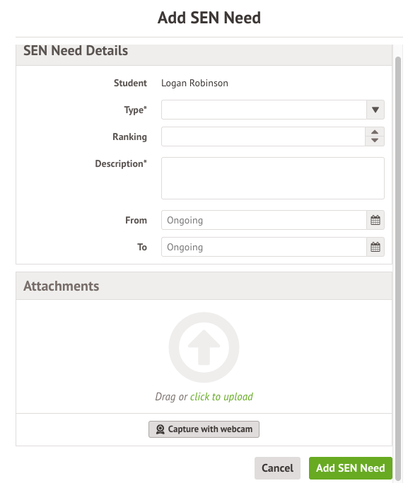

Pick the most appropriate need for the child from your assessments. They do not need a diagnosis for any option.

Always rank each need. Arbor does not automatically do this for you.

Do not use No Specialist Assessment – this type is no longer valid.

Do not use other difficulty/disability – this does not filter into one of the four COP areas.

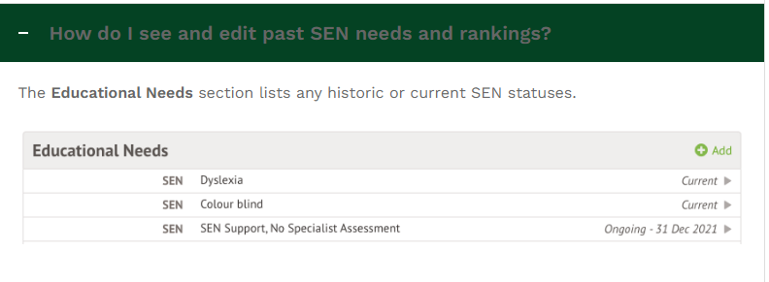

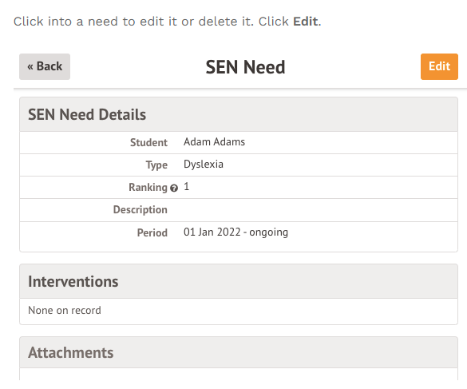

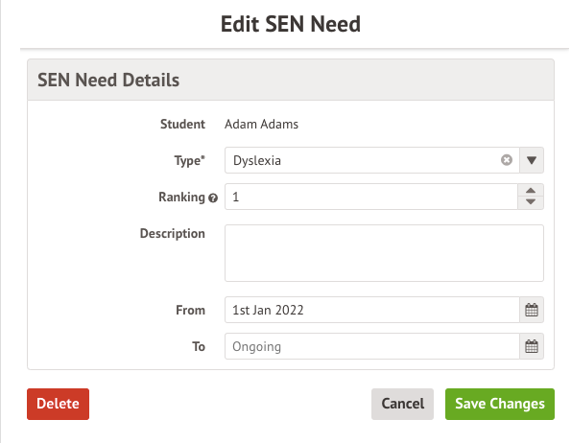

Other SEND Options that could be used:

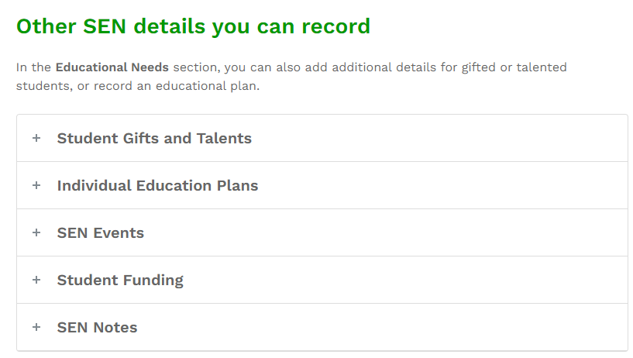

Link to Arbor Support: Adding SEN (Special Educational Need) for a student – Arbor Help Centre (arbor-education.com)

Running the SEND Register Using Arbor
Go to and click on Students (near top left), then Demographics, then Students with SEND
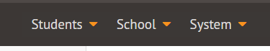
This can then be filtered and sorted within Arbor or Downloaded in Excel.
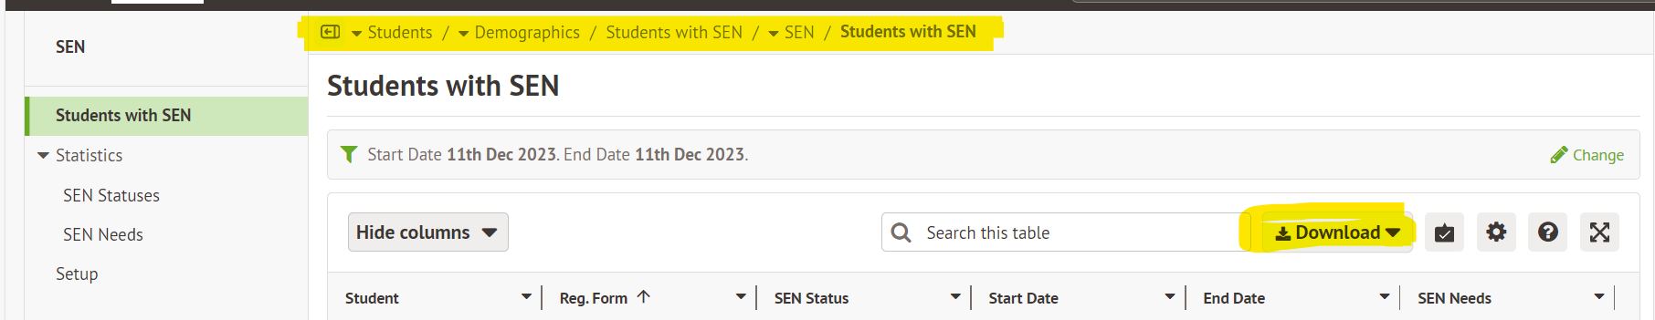

Running SEND Statistics and Percentages on Arbor

Go to and click on Students (near top left), then Demographics, then Students with SEND.

Select Statistics then SEN Statuses or SEN Needs for different reports.
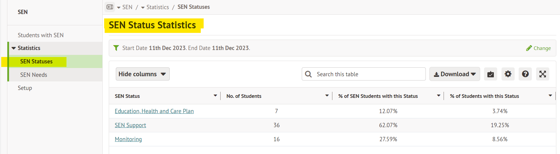

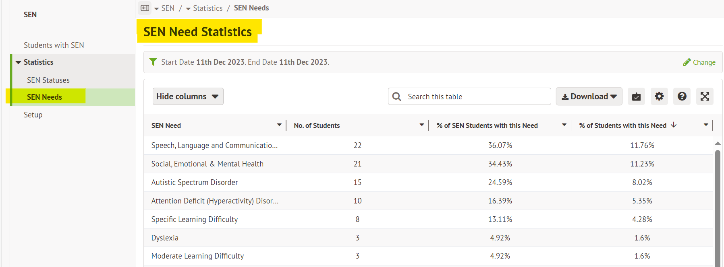
This can then be filtered and sorted within Arbor or Downloaded in Excel.

Appendix D – Pre-teach / Intervention provision map
